**Web Server**

**Steps:**

Run mount command



Check mount

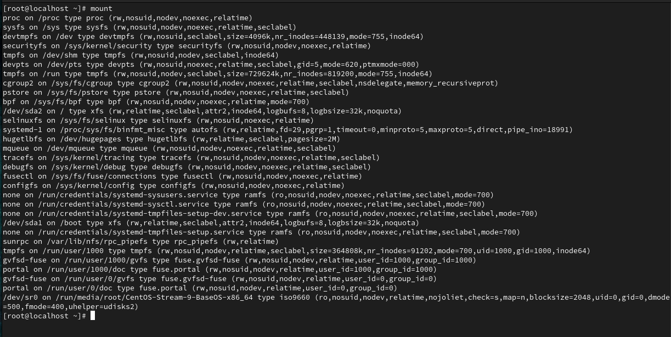

Create local.repo and rum yum clean all command

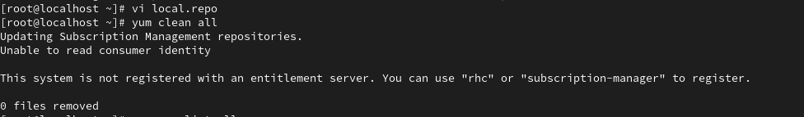

Rum yum repolist to check for repo

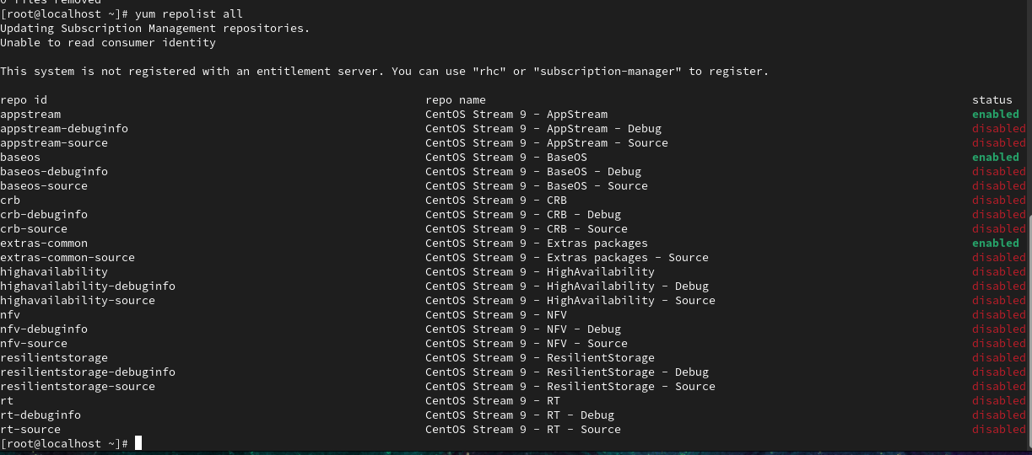

Install httpd and check for http server

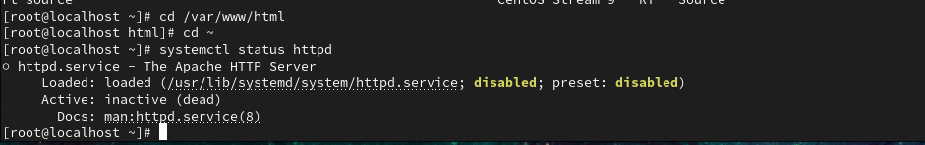

Check machine ip

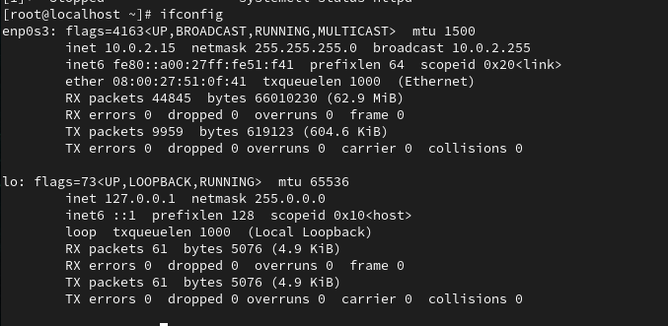

Activate Firewall and check system status

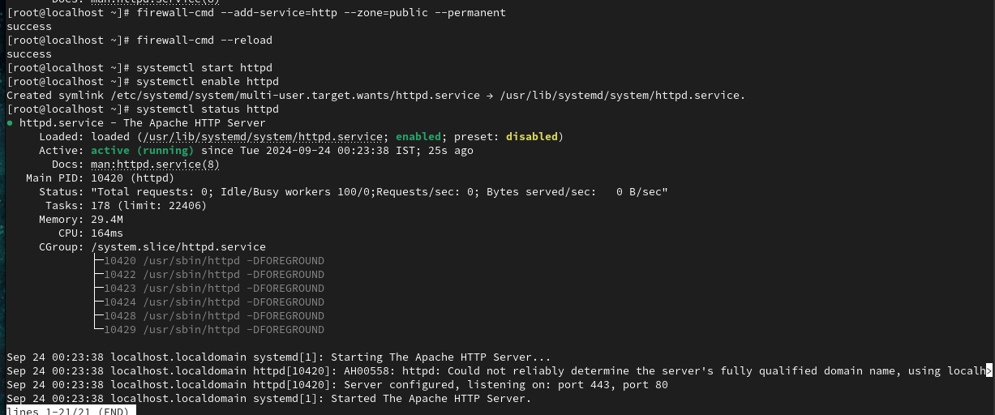

Output on browser